Handout P: Communication Performance of PAM vs. QAM Handout

Prof. Brian L. Evans

In the transmitter,
- Assume the bit stream on the transmitter side 0's and 1's appear with equal probability.
- Assume that the symbol period T is equal to 1.
In the channel,
- Assume that the noise is additive white Gaussian noise with zero mean. For QAM, the variance is σ² in each of the in-phase and quadrature components. For PAM, the variance is 2 σ². The difference is the variance is to keep the total noise power the same in QAM and PAM.
- Assume that there is no nonlinear distortion
- Assume there is no linear distortion
In the receiver,
- Assume that all subsystems (e.g. automatic gain control and symbol timing recovery) prior to matched filtering and sampling at the symbol rate are working perfectly
- Hence, assume that reception is synchronized with transmission
Given these mostly ideal conditions, the lower bound on symbol error probability for 4-PAM when the additive white Gaussian noise in the channel has variance 2 σ² is
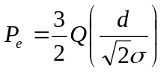
Given the 4-QAM and 4-PAM constellations below,
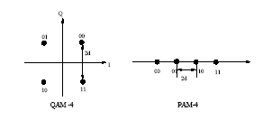
- Derive the symbol error probability formula for 4-QAM, also known as Quadrature Phase Shift Keying (QPSK), shown in Figure 1.

- Calculate the average power of the QPSK signal given d.

- Write the probability of symbol error for 4-PAM and 4-QAM as functions of the signal-to-noise ratio (SNR). Superimposed on the same plot, plot the probability of symbol error for 4-PAM and 4-QAM as a function of SNR. For the horizontal axis, let the SNR take on values from 0 dB to 20 dB. Comment on the differences in the symbol error rate vs. SNR curves.

- Are the bit assignments for the PAM or QAM optimal with respect to bit error rate in Figure 1? If not, then please suggest another bit assignment to achieve a lower bit error rate given the same scenario, i.e., the same SNR. The optimal bit assignment (in terms of bit error probability) is commonly referred to as Gray coding.

- Based on lecture notes on slides 15-13 through 15-15, the case of 4-QAM corresponds to having the four corner points in the 16-QAM constellation. So, the probability of correct detection is given by type 3 correct detection given on page 15-4 in the lecture notes. Since T=1, then the formula for the probability of correct detection is given by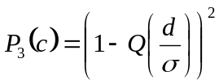. Thus the probability of error is given by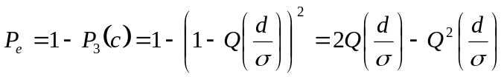.

b) To obtain the energy of , we notice that the sum of the squared coordinates will give you the energy of the signal . To see this, notice that is represented by the following vector 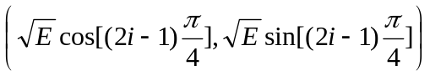in the 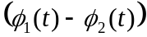coordinate system. Thus, it is immediate that 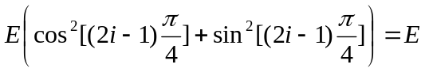. This implies that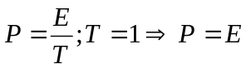.
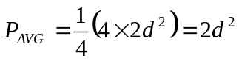.
c) SNR is defined as 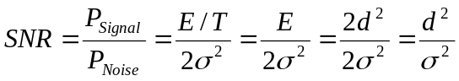 for the 4-QAM. For the 4-PAM, 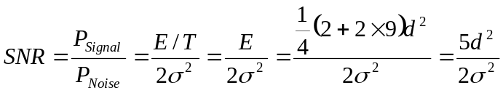. Substituting this into the P_{e} formula we obtain the following formulas:
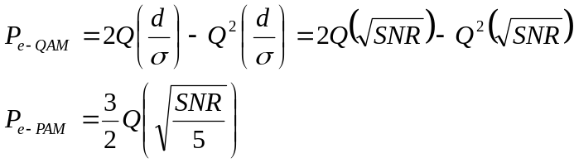

SNR = 0:20; % dB scale SNR
SNR_lin = 10.^(SNR/10); % linear scale SNR
Pq = 2*qfunc(sqrt(SNR_lin)) - (qfunc(sqrt(SNR_lin))).^2; % QAM error Probability
Pp = 3/2 * qfunc(sqrt(SNR_lin/5)); % PAM error Probability
semilogy(SNR,Pq, 'Displayname', '4-QAM');
hold on;
semilogy( SNR, Pp,'r','Displayname', '4-PAM');
title('4-PAM vs. 4-QAM Communication Performance');
ylabel('P_e'); xlabel('SNR (dB)');
legend('show');

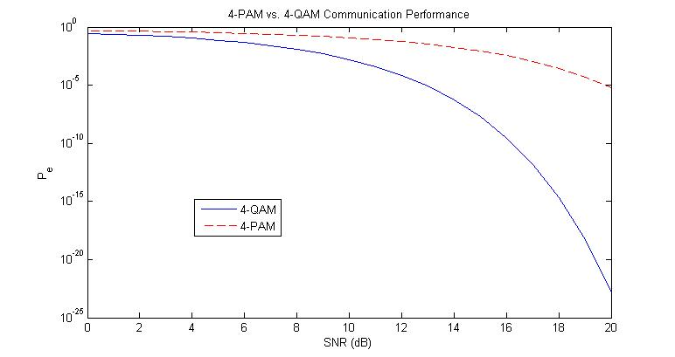
QAM performs much better than the PAM system due to the following reasons: first the noise variance in the PAM system is higher so we expect its error rate to be higher; on the other hand the PAM system is not fully utilizing the bandwidth as opposed to QAM.

d) The bit assignments are not optimal because the difference between the bits across the decision regions are more than one bit while they can be made one by using Gray Coding since each decision region has only two neighbors. The following bit assignment is optimal.
